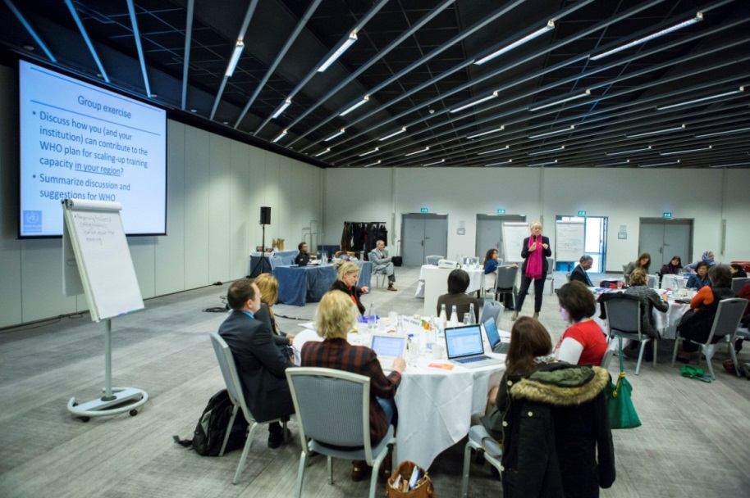
THE FIRST HEALTH IN ALL POLICIES TRAINING OF TRAINERS MEETING 2015
Geneva, Switzerland, 24-26 March 2015
DR. MARIA NEIRA
WHO Director, Department of Public Health Environmental and Social Determinants of Health (PHE)
Background
The WHO Health in All Policies Training Manual, launched in 2015, provides a resource for training to increase skills in working across sectors. It is designed to be used to organize workshops for health professionals and professionals from other sectors. Used by experienced trainers to target policy-making in the public sector, it aims to facilitate a mind-set shift to improve governance for health equity, through addressing social determinants of health (SDH), in the 21st century.
‘This is a training manual for you, but what you do with it, might never be called .. training ’
Prof. Ilona Kickbusch
Course director
Process
In March 2015, the World Health Organization held a meeting to train trainers in using the Health in All Policies training Manual. Participants were nominated by WHO regional office focal points, based on their existing networks over the period October 2014 -February 2015. The training programme was directed and developed by Ilona Kickbush, from the Graduate Institute of International and Development Studies, supported by Nicole Valentine (WHO HQ) and Carmel Williams (Government of South Australia) with key inputs by SDH leads and regional focal points [WHO HQ Dr. Eugenio Villar (Coordinator SDH) villare@who.int and Dr K.C. Tang (Coordinator Health Promotion) AFRO Dr. Davison Munodawafa mundodawafad@who.int; AMRO/PAHO Dr. Kira Fortune fortunek@who.int; EMRO Dr. Haifa Madi madih@who.int / Dr Faten Ben Abdelaziz benabdelazizf@who.int; EURO Dr. Christine Brown brownch@who.int; SEARO Dr. Suvajee Good goods@who.int; WPRO Dr. Anjana Bhushan bhushana@who.int]
Highlights and outcomes
- A total of 35 individuals participated in the training of trainers’ meeting of which 22 were from new external institutions identified by all six WHO regional offices to assist in scaling up training of trainers. Two participants represented experience from existing or newly-to-be-established WHO Collaborating Centres.

- Participants came with substantial experience in training, covering in their collective training experience 53 countries out of the 193 WHO Member States. Several had experience in intersectoral trainings. Key sectors that training institutions had prior experience with were education, agriculture, environment and urban planning and transport (see figure 1).

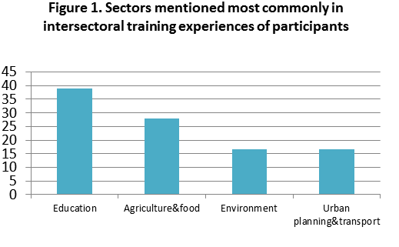

- Twelve modules of the training manual were reviewed, with a special emphasis on imparting skills related to complexity, negotiation, and framing.

- Participants were debriefed about the context of addressing health determinants in countries across a range of reproductive health, communicable and non-communicable diseases, as well as the context of strengthening universal health coverage. The context of the Sustainable Development Goals was also discussed.

- The use of training opportunities provided by the manual to advance action in countries was emphasized. Action was framed in two broad senses - implementation of the Rio Political Declaration on Social Determinants of Health and recent WHO resolutions, Contributing to social and economic development: sustainable action across sectors to improve health and health equity (67.12) and the WHO Framework for country action across sectors for health and health equity.
Resonance with training institutions and WHO collaboration
Institutions discussed supporting scale-up of training through :
- Reporting back to regional and country WHO staff
- Supporting regional and national training processes in countries when asked by national governments and WHO
- Providing training within their institutions and networks, and integrating module contents into existing courses
- Looking for financing flows and providing in-kind support to adapt and scale up use of the WHO training manual, as well as intergration of existing relevant tools.

In general, there was agreement that WHO efforts to support a network of trainers would enhance the effectiveness and speed of capacity building and skills development for working across sectors to promote health and health equity. A key element of WHO support for a network of trainers will be hosting a common data sharing e-platform. This platform will be launched later in 2015.

