- Select the cell studentNumber by clicking on the letter C.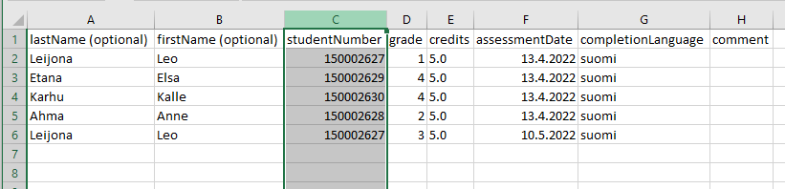
- Select Home > Conditional Formatting > Highlight Cell Rules > Duplicate Values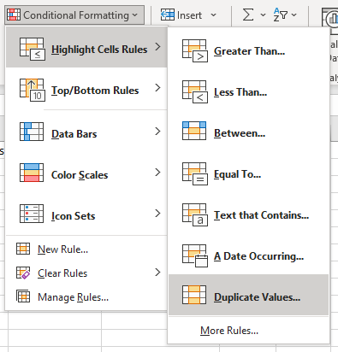
- Select OK
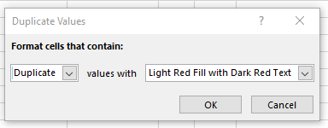
- The student numbers that appear in the table more than once will be colored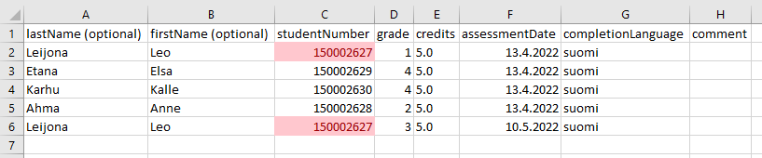
- Right-click the row number to select the row you want to delete. Then select Delete.
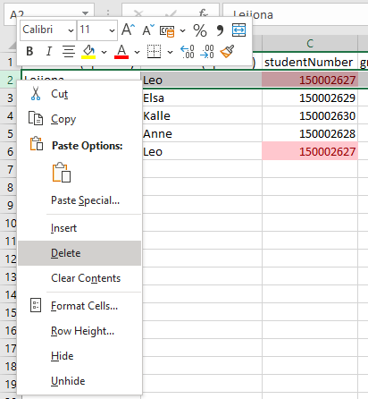
- Savet he file.

